NAME: Shriya Ramya Mohan
ROLL NO.: 241901106

EXPERIMENT 10
MITM ATTACK WITH ETTERCAP

AIM:
To initiate a MITM attack using ICMP redirect with Ettercap tool
ALGORITHM:
- Install ettercap if not done already using the command-
dnf install ettercap
- Open etter.conf file and change the values of ec_uid and ec_gid to zero from default.
vi /etc/ettercap/etter.conf
- Next start ettercap in GTK
ettercap -G
- Click sniff, followed by unified sniffing.
- Select the interface connected to the network.
- Next ettercap should load into attack mode by clicking Hosts followed by Scan for Hosts
- Click Host List and choose the IP address for ICMP redirect
- Now all traffic to that particular IP address is redirected to some other IP address.
- Click MITM and followed by Stop to close the attack.

OUTPUT:
[root@localhost security lab]# dnf install ettercap
[root@localhost security lab]# vi /etc/ettercap/etter.conf
[root@localhost security lab]# ettercap –G

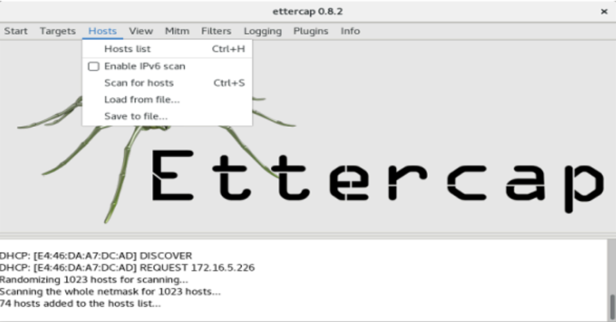
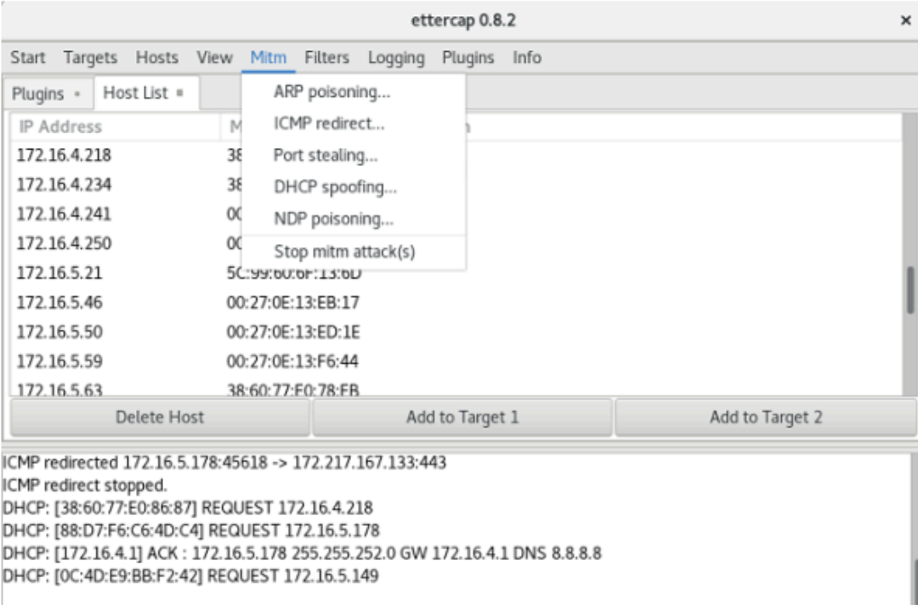
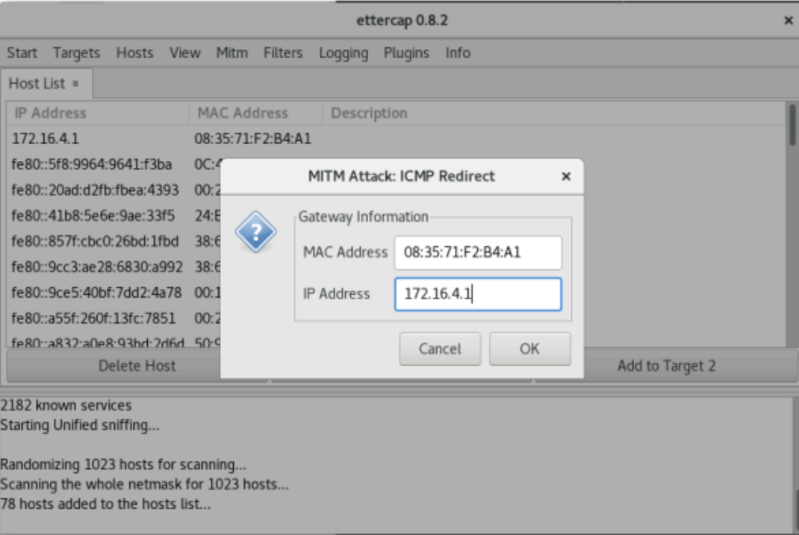
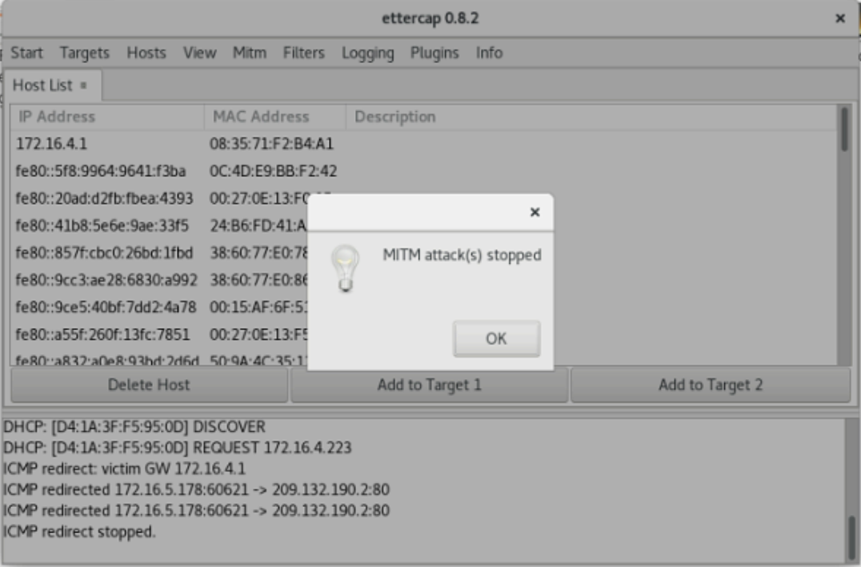
RESULT:
Thus the MITM attack has been successfully executed using Ettercap tool.

